Web Technologies

Task 4

(BSCS)

By
Sr | Name | Roll.  Number | Section
1 | Naeem Saleem | Fa-2023-Bscs-250 | G

Supervised by:

Mr. Muhammad yosaf



Department of Computer Science
Lahore Garrison University
Lahore

Lab 4: Forms & Multimedia

Lab 4: Forms & Multimedia — Step-by-Step Solution
Objectives Recap
- Create an accessible HTML feedback form.
- Embed audio and video.
- Use <canvas> for basic static drawing.

\‘z’ Tools Required
- VS Code (code editor)
- Live Server (for preview)
- W3C Validator (for form validation)

Step 1: Create the HTML Structure
<!DOCTYPE html>
<html lang="en">
<head>
<meta charset="UTF-8">
<title>Lab 4: Feedback Form & Multimedia</title>
</head>
<body>
<h1>Feedback Form</h1>
<form action="#" method="post">
<!-- Name Input -->
<label for="name">Name:</label>
<input type="text" id="name" name="name" required placeholder="Enter your name"><br><br>

<!-- Email Input -->
<label for="email">Email:</label>
<input type="email" id="email" name="email" required placeholder="Enter your email"><br><br>

<!-- Gender Radio Buttons -->
<label>Gender:</label>
<input type="radio" id="male" name="gender" value="male">
<label for="male">Male</label>
<input type="radio" id="female" name="gender" value="female">
<label for="female">Female</label><br><br>

<!-- Interests Checkboxes -->
<label>Interests:</label>
<input type="checkbox" id="coding" name="interest" value="coding">
<label for="coding">Coding</label>
<input type="checkbox" id="design" name="interest" value="design">
<label for="design">Design</label><br><br>

<!-- Select Dropdown -->
<label for="experience">Experience Level:</label>
<select id="experience" name="experience">
<option value="">Select</option>
<option value="beginner">Beginner</option>
<option value="intermediate">Intermediate</option>
<option value="advanced">Advanced</option>
</select><br><br>
<!-- Textarea -->
<label for="comments">Comments:</label><br>
<textarea id="comments" name="comments" rows="4" cols="50" placeholder="Your feedback..."></textarea><br><br>
<!-- Submit Button -->
<input type="submit" value="Submit">
</form>

Step 2: Embed Audio and Video
<h2>Multimedia Demo</h2>

<!-- Audio -->
<audio controls>
<source src="sample-audio.mp3" type="audio/mpeg"> Your browser does not support the audio element.
</audio><br><br>

<!-- Video -->
<video width="320" height="240" controls>
<source src="sample-video.mp4" type="video/mp4"> Your browser does not support the video tag.
</video><br><br>

Step 3: Add Canvas Drawing
<h2>Canvas Demo</h2>
<canvas id="myCanvas" width="200" height="100" style="border:1px solid #000000;"></canvas>

<script>
const canvas = document.getElementById("myCanvas"); const ctx = canvas.getContext("2d");
ctx.fillStyle = "#FF0000";
ctx.fillRect(20, 20, 150, 50); // Draw a red rectangle

</script>
</body>
</html>
<!DOCTYPE html>
<html lang="en">
<head>
<meta charset="UTF-8">
<meta name="viewport" content="width=device-width, initial-scale=1.0">
<title>Lab 4: Feedback Form & Multimedia</title>

<style>
body {
font-family: Arial, sans-serif;
background-color: #fafafa;
margin: 20px;
}

h1, h2 {
text-align: center;
}

form {
background-color: #ffffff;
padding: 15px;
border: 1px solid #ccc;
width: 400px;
margin: 0 auto;
border-radius: 5px;
}

label {
display: inline-block;
width: 120px;
margin-top: 10px;
}

input, select, textarea {
margin-top: 5px;
}

input[type="submit"] {
margin-top: 15px;
background-color: lightblue;
border: 1px solid #999;
padding: 5px 10px;
cursor: pointer;
}

audio, video {
display: block;
margin: 10px auto;
}

canvas {
display: block;
margin: 10px auto;
border: 1px solid #000;
}
</style>
</head>

<body>
<h1>Feedback Form</h1>

<form action="#" method="post">
<!-- Name Input -->
<label for="name">Name:</label>
<input type="text" id="name" name="name" required placeholder="Enter your name">
<br><br>

<!-- Email Input -->
<label for="email">Email:</label>
<input type="email" id="email" name="email" required placeholder="Enter your email">
<br><br>

<!-- Gender Radio Buttons -->
<label>Gender:</label>
<input type="radio" id="male" name="gender" value="male">
<label for="male">Male</label>
<input type="radio" id="female" name="gender" value="female">
<label for="female">Female</label>
<br><br>

<!-- Interests Checkboxes -->
<label>Interests:</label>
<input type="checkbox" id="coding" name="interest" value="coding">
<label for="coding">Coding</label>
<input type="checkbox" id="design" name="interest" value="design">
<label for="design">Design</label>
<br><br>

<!-- Select Dropdown -->
<label for="experience">Experience:</label>
<select id="experience" name="experience">
<option value="">Select</option>
<option value="beginner">Beginner</option>
<option value="intermediate">Intermediate</option>
<option value="advanced">Advanced</option>
</select>
<br><br>

<!-- Textarea -->
<label for="comments">Comments:</label><br>
<textarea id="comments" name="comments" rows="4" cols="40" placeholder="Your feedback..."></textarea>
<br><br>

<!-- Submit Button -->
<input type="submit" value="Submit">
</form>

<h2>Multimedia Demo</h2>

<!-- Audio -->
<audio controls>
<source src="sample-audio.mp3" type="audio/mpeg">
Your browser does not support the audio element.
</audio>

<!-- Video -->
<video width="320" height="240" controls>
<source src="sample-video.mp4" type="video/mp4">
Your browser does not support the video tag.
</video>

<h2>Canvas Demo</h2>
<canvas id="myCanvas" width="200" height="100"></canvas>

<script>
const canvas = document.getElementById("myCanvas");
const ctx = canvas.getContext("2d");
ctx.fillStyle = "red";
ctx.fillRect(20, 20, 150, 50); // draw a red rectangle
</script>
</body>
</html>

Final Deliverables
- feedback-form.html with:
  - Accessible form (labels, placeholders, validation)
  - Embedded audio and video
  - Canvas with static drawing
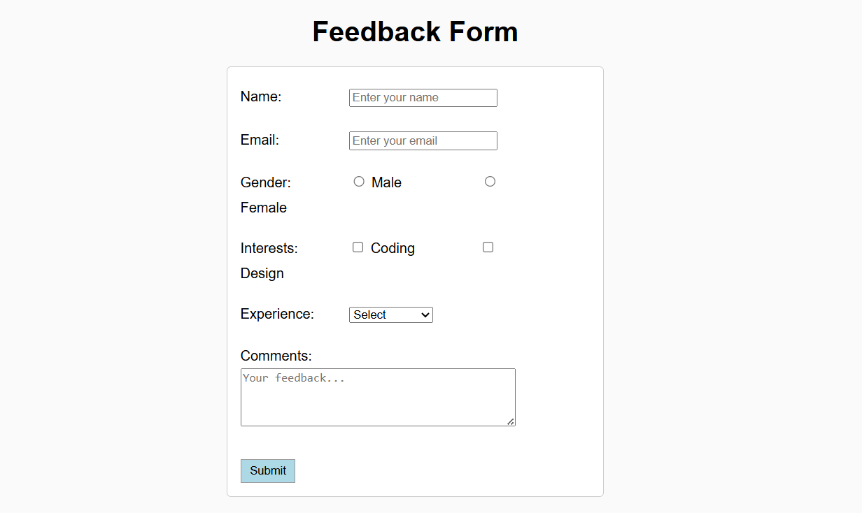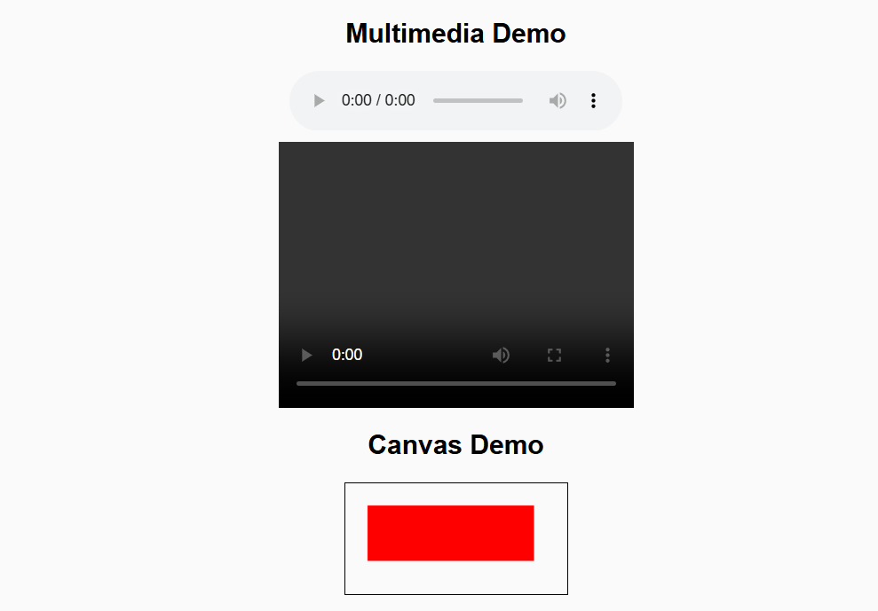

CONCLUSION:

RUBRICS:

Performance |  |  | Lab Report
Description | Total Marks | Marks Obtained | Description | Total Marks | Marks Obtained
Ability to Conduct practical | 5 |  | Structure | 5
Data Analysis s Interpretation | 5 |  | Efficiency | 5

Total Marks obtained |  | Total Marks Obtained

Instructor Signature

